The Broader Impact Of DSP
The Impact of the DSP from an Economic, Social, and Global context

Karthik Calanji Sridhar
Department of Electrical and Computer Engineering
Old Dominion University
Norfolk VA 23508 USA
kcala002@odu.edu

Abstract—Digital signal processing is the process of modifying a signal to enhance its performance. Digital signal processing is important because it enhances many aspects of life, such as it being very efficient. Digital signal processing is efficient because it enables people to get whatever job they are performing, done in a more practical and cost efficient manner. Digital Signal processing is used almost everywhere around the globe. It is most primarily used in the areas of voice recognition, RADAR, SONAR, speech processing and many more fields. For example, Digital signal processing is used for voice recognition on, mobile phones to enable a user to gain access to the virtual assistants contained in most smartphones. This paper will mainly focus its attention on the broader impact of Digital Signal Processing, from an economic, social, and global context.
Keywords-Digital Signal Processsing; voice recognition; speech processing; signals; signal processing.
Introduction
Digital signal processing is a very distinct field that revolves around midifying a signal to enhance its performance and then use the improved signal for another more complex process. Digital signal processing involves many different processes such as filtering, programming, analyzing, and recoring. There are several key components that are required in digial signal processing in order to ensure the process works without fault and more efficiently. These crucial components include a program memory, a data memory, a compute engine, an input and an output. Each of these components serve a different purpose. The program memory is what stores the programs the digital signal process uses in order to process data. The data memory is what stores the information that needs to be procesed. The purpose of the compute engine is to perform the math processing, while accessing the information from the program memory and the data from the Data memory. Finally the Input/Output is tasked with serving a range of functions to connect to the world. Over the past several years dgital signal processing has grown in importance, mainly in the fields such as electronics, audio systems, RADAR, SONAR, and medical equipment such as MRI machines.
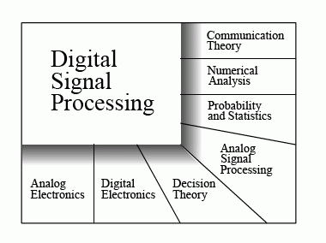

Figure 1: The wide range of fields where Digital signal processing is used and overlaps with science, mathematics, and engineering [1].
Digital signal processing can be traced back all the way back to the 1960s and 1970s. Back then digital signal proceessing was mainly used in systems that required SONAR and RADAR systems. This was mainly because the computer and other devices such as: the telephone were just being introduced into the world, following the rules of Moore’s Law these were expensive and buly devices that many households could not afford. As computers began to evolve digital signal processing grew in popularity and advancements in engineering were made. As the devices became cheaper and more capabl, many households and businesses began utilizing devices that used DSP.
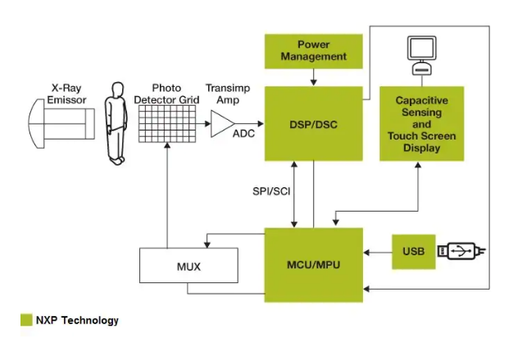
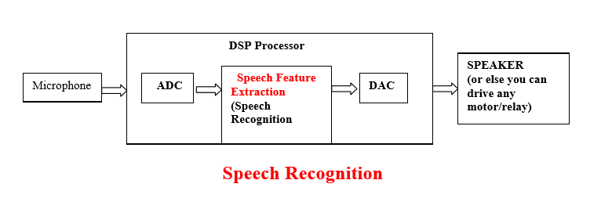
Digital signal processing has become very popular in the field of medical imaging. Since medical imaging is constantly changing and advancing, DSP also has to keep up with its evolution. A major example of advancement in DSP is the transfer of X-Rays from film to digital files. Since digital systems were introduced, the signals produced from X-Rays could be converted into files that are digital. This offers medical doctors some major advantages. First off, when the signals are transferred, there are no hiderances in image quality. This increased image clarity enables doctors to view an accurate image before performing any higly precice procedure on a patient. The second advantageDSP offers is that it eliminates the time and costs it previously incurred when processing the film the X-ray images were taken on.

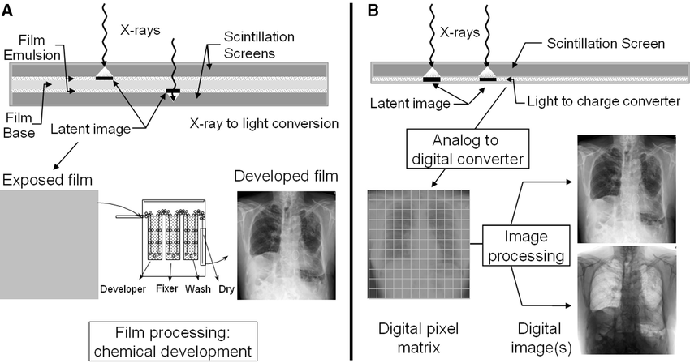
Figure 2: Block diagram showing how DSPs are used to conver t X-Ray signals of patients [2].

Figure 3:Diagram showing the diffence between using chemical development and DSP to develop X-Ray images[3].

Another significant field that depends on digital signal processing is the field of speech processing.In the late 2000’s, when speech recognition wasn’t as robust as it is today, many developers were very hesitant to release any applications that involved speech recognition because of the high ratio that something would become faulty. Thanks to the advancements in DSP techniques, the accuracy rates with speech recognition were increased drastically. Some of the barriers that DSP could now solve were simple issues such as overcoming background noise and noise reduction.

Figure 4: Model displaying how Digital Signal Processing is used to read a person’s voice in the field of speech recognition[4].
Digital signal processing does this by first analyzing each small segment of speech and then the important characteristics are placed into a feature vector. Next, as each segment of speech is analyzed, it will count the basic sound of each letter. If noise or some other form of disturbance occurs, a mispronounciation may occur leading to an innaccuracy. What Digital signal processing does is use the aid of filters to overcome background noise and noise reduction. These complex filters are the reason why DSP could offer such high accuracy in speech recognition. If one were to reconfigure the analog system it would also mean that one would also be forced to completely redesign the system hardware. With the help of digital signal processing, it offers faultless control of the accuracy for speech recognition. DSP’s cost effectiveness is one of the prime reasons it is used in speech recognition. When compared to analog, the environment that DSP has to be implemented in is very inexpensive. In the near furture, the scope for DSP in voice and speech recognition only grows. Soon there might be global positioning systems that implement the voice recognition feature using signal processing, where a person speaks a location to the GPS and the GPS automatically recognizes and returns directions to the user. Voice recognition features for GPS’s have already been implemented into various smartphone devices. As technology advances, this will become implemented into almost all handheld devices as well as carsand refridgerators, therefore reducing the need for the user to physically enter a destination.
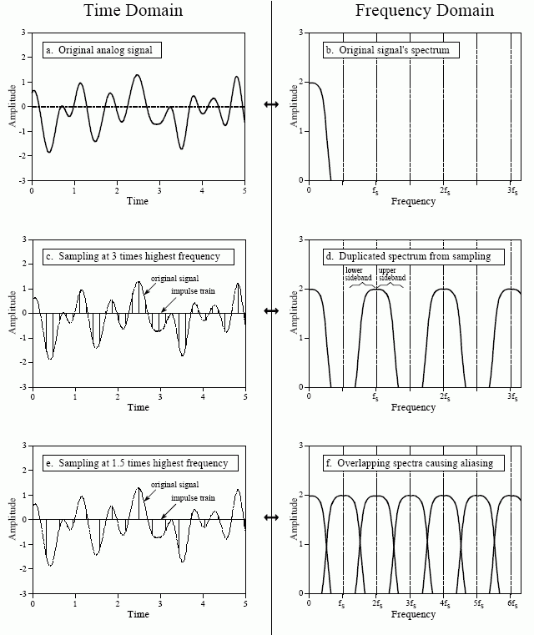

Figure 5: Chart showing how an analog voice signal is converted using DSP[5].
Economic Impact
With Digital Signall Processing being introduced into the world, one of the major contributions of DSP was the creation of many jobs. Digital signal processing has opened up many scopes of jobs beginning with engineers who develop complex electronics and electronic systems such as embeded systems, microcontrollers and microprocessing units. Another scope of jobs that have emerged from the development of DSPs are theworkers who set up the infrastructure needed to run wireless communication, such as mobile networks. For example, the third generation will require a different infrastructure than the second generation, just as the fourth generation differs from the second and third generations.
DSP has also grown tremendously in the areas of automation and robitics. In robotics specifically, signal processing ensures that there is enough sensor data for the robot and also makes certain that future autonomous actions are controlled and that communication lines are working optimally. Some of the applications of signal processing in the robotic sector include autonomous navigation, remote health moitoring , and home security with infared sensing for mapping the environment both outside and inside the home. DSP is gradually continuing to provide a stable platform for new jobs in machine learning and artificial intelligence.
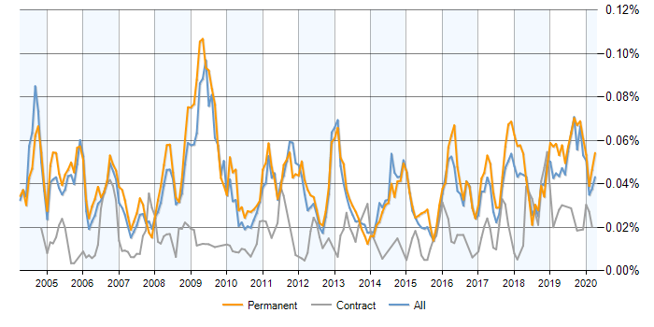

Figure 6: A graph displaying gthe job prospects in DSP in the United Kingdom[6].
As one can see in figure 6 above, the number of jobs in the United Kingdom, related to DSP is making a gradual increase. As digital signal processing advances, the need for people whose expertise lies in those fields also will increase. With the evolution of DSP companies are able to maximize production and regulate production cost depending on the supply and demand. This will then lead to more profit being generated.
Social Impact
The social impact of digital signal processing has had an equal impact on the world if not more than the economic impacts. Two major examples world be the internet and modern communication systems, in the last two decades access to the internet has provided the world with so many advancements in areas such as communication, banking, online shopping, and it has even enabled people to bring their work home. The internet has helped with communications by revolutionizing mail, teleconferences, and family contacts in the ways of the telephone and email. All of these entities require signl processing. Telephones require signal processing because it is what takes a person’s voice and converts it to a signal that gets transferred to the reciever’s phone and reconstructed into recognizable speech. The same concept works with email when the computer converts the email message into a binary form and then processes the message and sends it to the recieveing host to convert back into a form that the person can read and understand. Because of the processes of Digital Signal processing, people no longer have to use the normal mail service to send a simple message that would take days to deliver. DSP has also changed how mobile banking works. Banking has become more secure than ever with the help of DSP and the internet. Dual factor authentication and encryption of personal data through the use of DSP and the internet have increased security of transactions tenfold compared how it was two decades ago. Telecommunication has made a big impact on television and other mobile platforms too. Corporations can reach out to more people to and advertise their products to a greater audience . Telecommunication is also widely used to educate people and increase their awareness of what is happening around the world with one touch of a button. This was all possible because of digital signal processing.
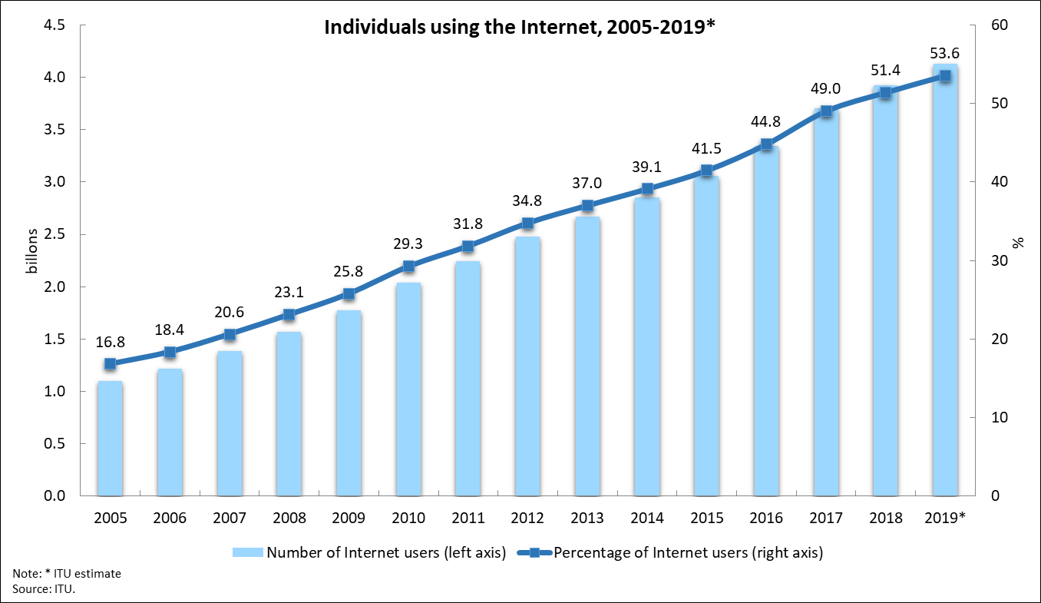

Figure 7: Chart displaying the growth of internet use over the past 14 years[7].
Global Impact
The development of communnication and the internet has made the online community for people very prominicious. The use of digital signal processing has made it possible to receive information about anything, virtually anywhere around the world, such as viewing news about a faraway country from the leisure of your home. Without the large scale implementataion of DSP, the work from home culture created by COVID-19 would not be possible. DSP has played a major role in the globalization of the world, since it has made it much easier to access information from any time anywhere in the world given that there is a stable network/internet connection.
Conclusion
In this decade of information, a lot of the technology that we end up using is based upon digital signal processing. Most of the devices we use today have the DSPs embedded. The daily use of DSPs will contribute immensly to the development of technology and our future. As shown in this paper DSP has had a significant impact in the economic, social ,and global context in how we live our lives.
References
[1]* F. Nebeker, The IEEE signal processing society: fifty years of service, 1948 to 1998. New Brunswick, NJ: IEEE History Center, 1998.
[2]* J. Goldthwaite, “The Value of Digital Signal Processing,” Industrial Noise Cancelling Headsets For Work. [Online]. Available: https://www.sensear.com/blog/the-value-of-digital-signal-processing. [Accessed: 20-Apr-2020].
[3]* “A Beginner's Guide to Digital Signal Processing (DSP),” A Beginner's Guide to Digital Signal Processing (DSP) | Design Center | Analog Devices. [Online]. Available: https://www.analog.com/en/design-center/landing-pages/001/beginners-guide-to-dsp.html#. [Accessed: 21-Apr-2020].
[4]* “Speech Recognition using Digital Signal Processing,” Technosoft Innovation, 02-Apr-2019. [Online]. Available: https://technosoftinv.com/speech-recognition-using-digital-signal-processing/. [Accessed: 22-Apr-2020].
[5]* K. KaurApr, “Signal Processing in Robotics,” AZoRobotics.com, 10-Apr-2013. [Online]. Available: https://www.azorobotics.com/Article.aspx?ArticleID=98. [Accessed: 22-Apr-2020].
Image References
[1] “The Scientist and Engineer's Guide toDigital Signal ProcessingBy Steven W. Smith, Ph.D.,” The Roots of DSP. [Online]. Available: https://www.dspguide.com/ch1/1.htm. [Accessed: 19-Apr-2020].
[2] “Digital X-Ray,” NXP. [Online]. Available: https://www.nxp.com/applications/solutions/industrial/healthcare/digital-x-ray:DIGITAL-XRAY. [Accessed: 19-Apr-2020].
[3] J. A. Seibert and J. M. Boone, “FIGURE 11. Analog (A) and digital (B) x-ray image acquisition is...,” ResearchGate, 01-Aug-2018. [Online]. Available: https://www.researchgate.net/figure/Analog-A-and-digital-B-x-ray-image-acquisition-is-depicted-In-each-situation-x-rays_fig11_8002654. [Accessed: 21-Apr-2020].
[4] F. A. F. Y. People and Healthcare, “Speech Recognition Using DSP Processor [Case Study],” Entc Engg, 29-May-2017. [Online]. Available: http://www.entcengg.com/speech-recognition-using-dsp-processor/. [Accessed: 22-Apr-2020].
[5] “The Scientist and Engineers Guide toDigital Signal ProcessingBy Steven W. Smith, Ph.D.,” Digital-to-Analog Conversion. [Online]. Available: https://www.dspguide.com/ch3/3.htm. [Accessed: 22-Apr-2020].
[6] “Digital Signal Processing Jobs,” Digital Signal Processing jobs, average salaries and trends for Digital Signal Processing skills | IT Jobs Watch. [Online]. Available: https://www.itjobswatch.co.uk/jobs/uk/digital signal processing.do. [Accessed: 22-Apr-2020].
[7] Statistics. [Online]. Available: https://www.itu.int/en/ITU-D/Statistics/Pages/stat/default.aspx. [Accessed: 23-Apr-2020].

